**Object Oriented Analysis and Design**

|  |  |
| --- | --- |
| **Class** | -> blue print of an object  -> describes the state and behaviour of the object  -> it contains Attributes and methods. |
|  | |
| **Access Specifiers**  private -  protected #  public + |  |
| **Association** | |
| **Aggregation** | |
| **Composition** | |
| **Inheritance** | |

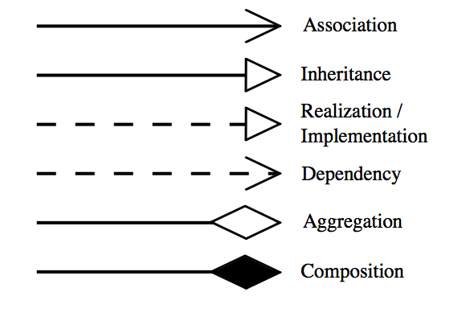

## Generalization vs Specialization